**Human Computer Interaction Project**

**Space Raiders**

**Uğur Kaya Küçükkaptan 216CS2019**

For project work of this course, i was planning on creating a game as a project.I was actually thinking of using a game engine called ‘RPGMakerMv’ to create a game for this course but i hesitated if it would be appropriate or not.So i decided to use python as previous homeworks i did.With python instead of the default ‘tkinter’ gui i went on to use another gui module that was more friendly towards game making and used by many named ‘pygame’.I must tell that in order to run this python file,’pygame’ module must be installed on python.

Requires pygame module to run.

INSTRUCTIONS: Arrow Keys to move,Space bar to shoot.

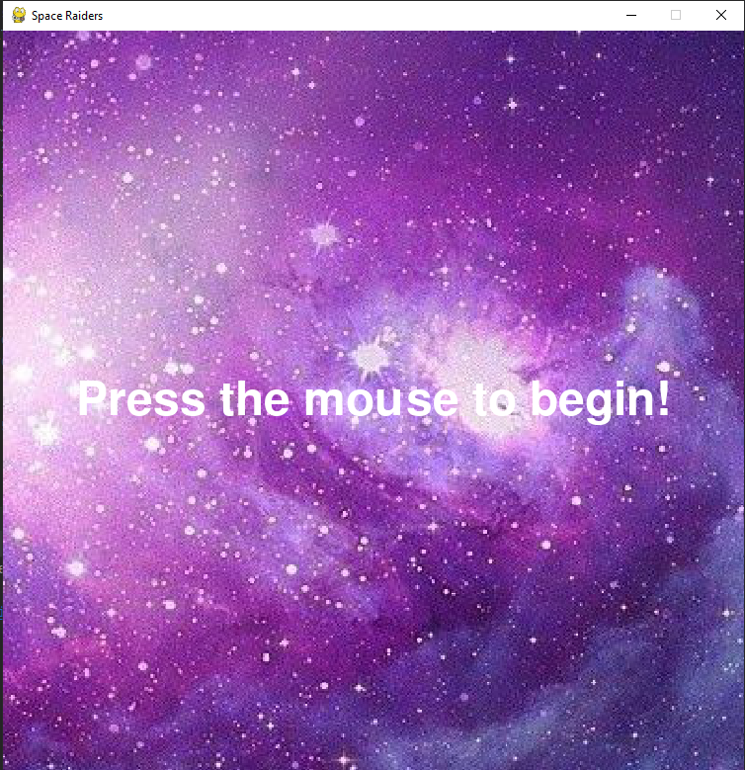

This is the title screen.Just by mouse click game can start.

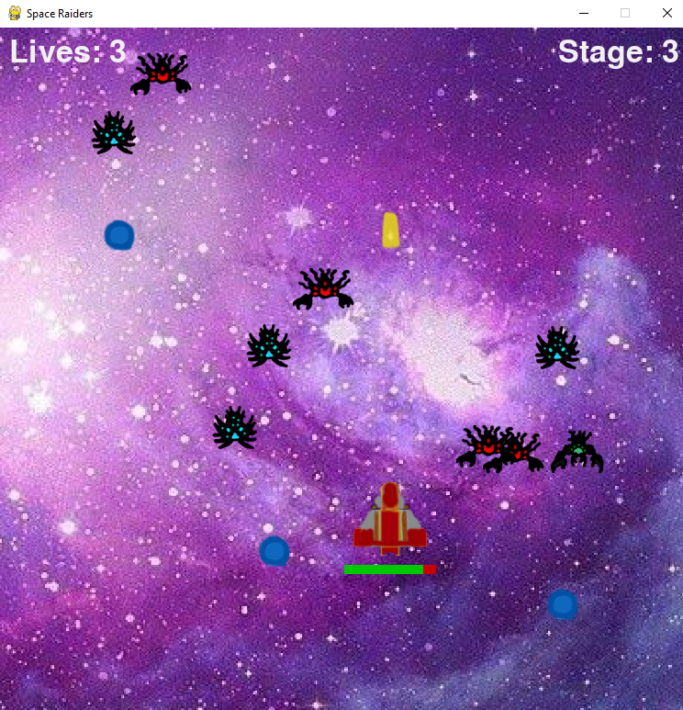

This is the main gameplay screen.This is basically how the game looks like.The point of the game is to prevent enemies from reaching at the bottom of the screen by shooting them.If they reach, you lose a life.Enemies also shoot you,so you have a lifebar at the bottom of the player spaceship.If your healthbar becomes all red or your lives become 0 by enemies reaching bottom,the game ends.As we move through the stages, controls are arrow keys to move, and space to shoot.As the stage increases the waves that enemies come in gets tougher,so the game gets harder.I was planning on adding more enemies,power ups and boss fights but did not had enough time because of final schedules,but plan on adding them after the semester is over.

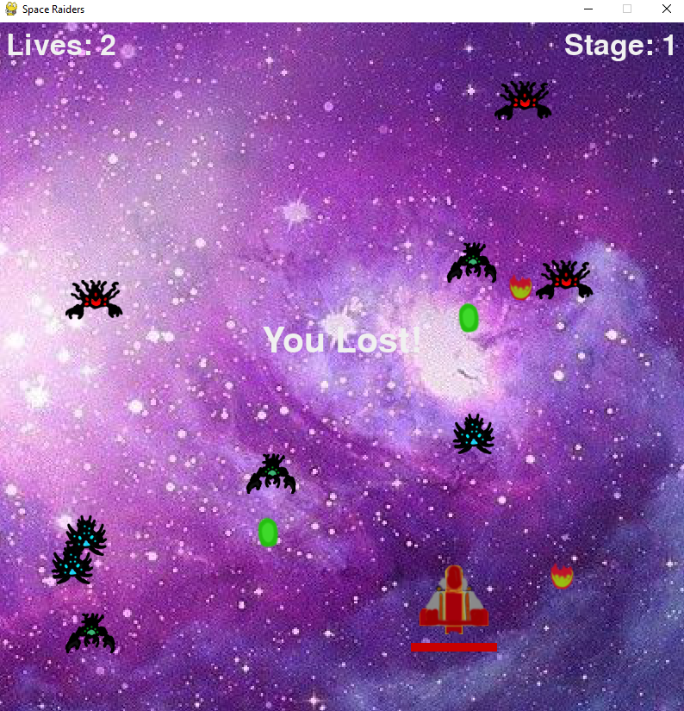

And this is the game over screen,when your healthbar becomes all red.

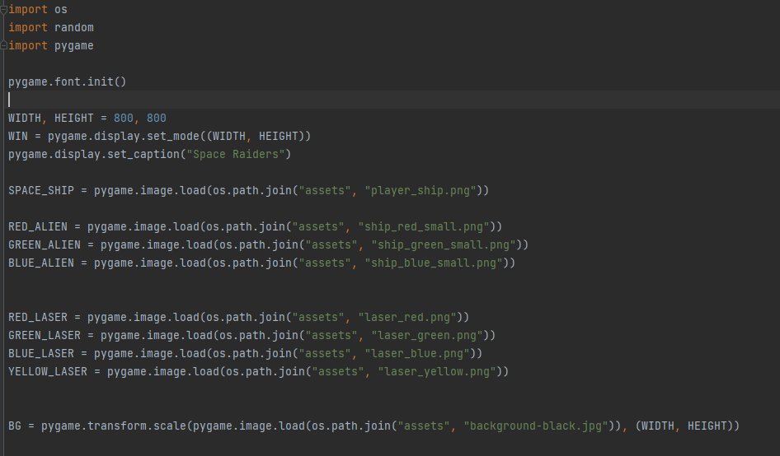

This is where the board is set and assets implemented and assigned into the code.In game assets are drawn by me except the background image.

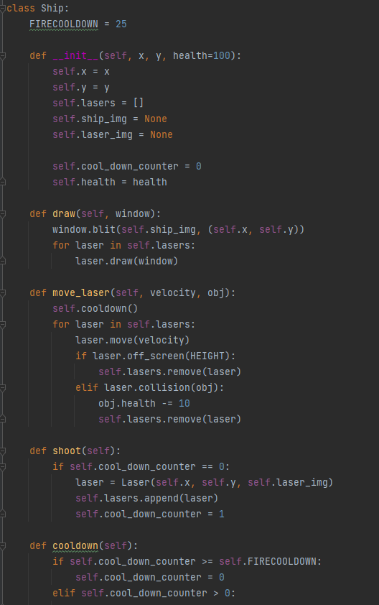

Ship is a abstract class where i used to inherit abilites for enemy ships and player main ship. Properties of the ships have their starting positions which is determined by the positions of x and y and they fire lasers both enemies and our player ship.By using this abstract class i can create multiple instances of ships that have their own x and y coordinates and healths.Firecooldown given here is a delay so that the players just dont hold press space button which is fire button and obliterate everything on screen.If a laser goes out of screen,it is removed as it should be.Move_laser method is handles the laser moving parts and if it collides re-checks the object health.Lasers moving speed comes from main methods initialized velocity value.

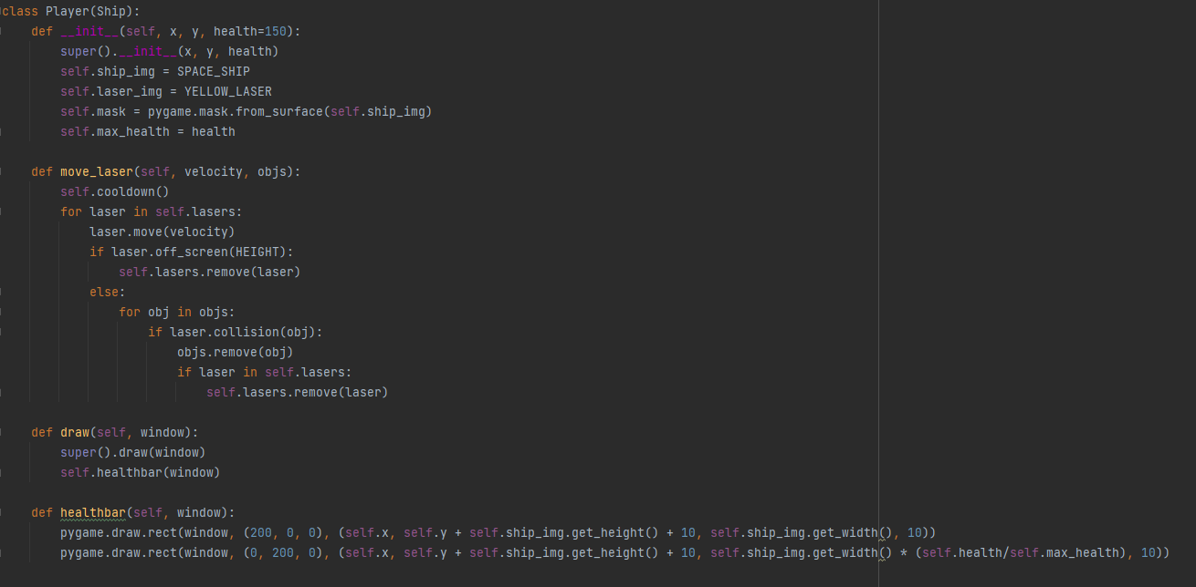

Player ship is the main ship we control to combat aliens.It inherits attributes from ship abstract class.Super constructor is called.Healthbar is used by pygame.draw functionality shows the healthbar of the user under the ship.It uses the asset thats in asset folder.Pygames mask functionality gives pitch perfect collision control on surfaces.Draw method here draws the wanted functionalities inside of a class which in this case is window and healthbar under the player ship.Same as before velocity is the moving speed of laser.

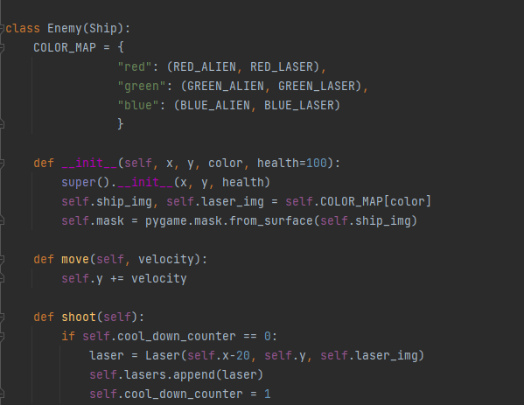

Just like player ship, enemy ship essentially is the class that takes from asset folder and moves up from downwards.So they should be shot.Mask again is used.Color map determines the enemy type,for example if COLOR_MAP is generated red from main method,enemy will be red alien that is using red laser.Enemies can only move from up to down in order to reach bottom.So their y values will keep updated.

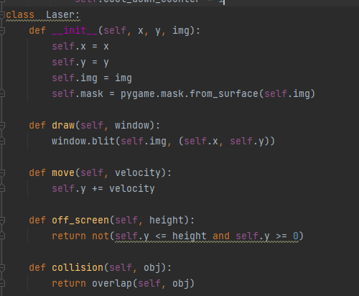

Since all lasers are unique to the type of character such as red alien,blue alien,green alien and player a laser object is created.Image is passed from the ship class because it is created from ship since they are firing.self.mask is also used since lasers collide with ships.If a laser is shot it should be going to the upwards or enemy shoots,it should keep going bottom.

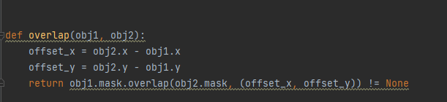

This def is essentialy the collision control functionality.Object height and width are a square around the circular object because of the png uploaded as asset object.When something hits the object,it should hit the objects pixels, not the empty rechtangular area around the object.

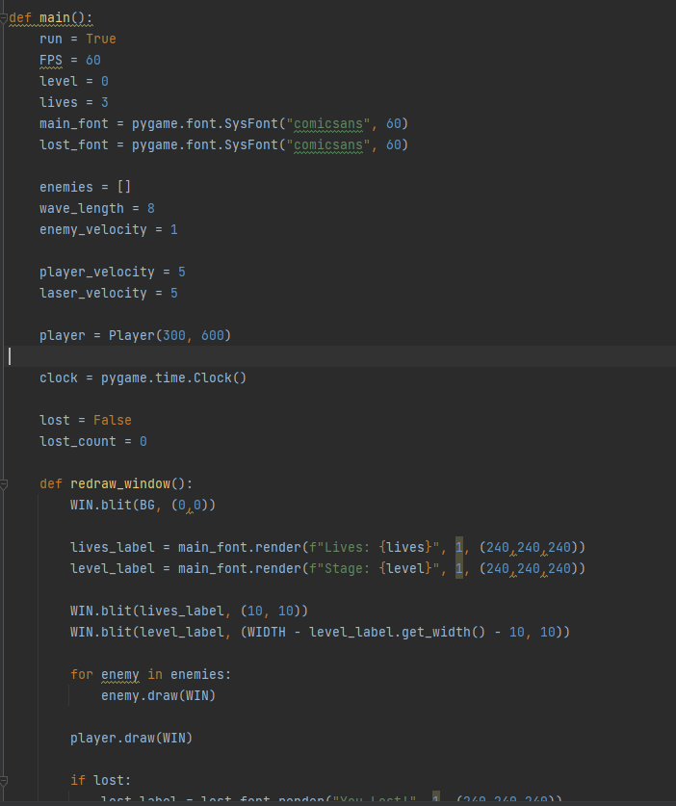

This is the main method.I gave variable FPS 60 values and used clock tick to set it into 60 fps so in any pc that the game opens,it stays the same 60 fps.If i remove that value game would be unplayable and it would be over before user could react on fast computers.Amount of , lives,wavelength, players moving speed,enemy moving speed and laser velocity are also initalized here.

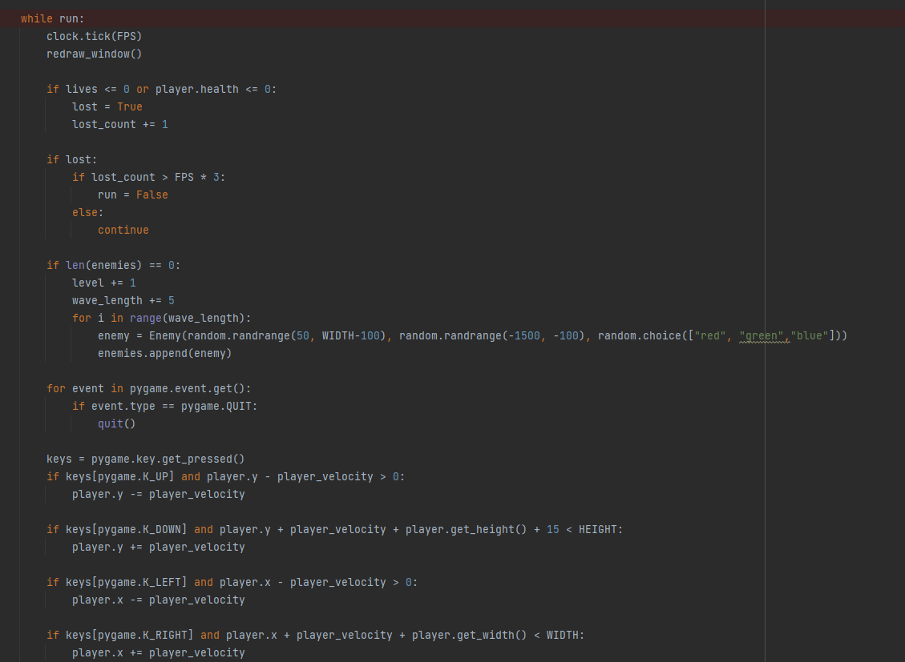

While on run loop,game runs.Arrow key movement and space shoot is given pygame.key.get.pressed.If lives reaches 0 game stops running.When enemy count reaches zero a stage ends and next stage begins.So wave length increases by 5 each time a level is passed to add more enemies.Enemies are generated randomly on well above the screen each time,they spawn all at once in negative position and they move down slowly at same velocity and since they all spawned in random heights they look like they are all coming down at different times when that is not the case.If they are really lucky they may overlap but that is fine, .random.randrange functions covers these functions.The colors are also randomly selected so every round has random colored aliens.The loop here is that when the lives reaches zero, game halts and checks the FPS*3.Since the game over screen is always and always 1 FPS,just showing one window it gives a 3 second timeout,and then the program stops the run,on else situating it just redraws the window.And with that main functionality is done.

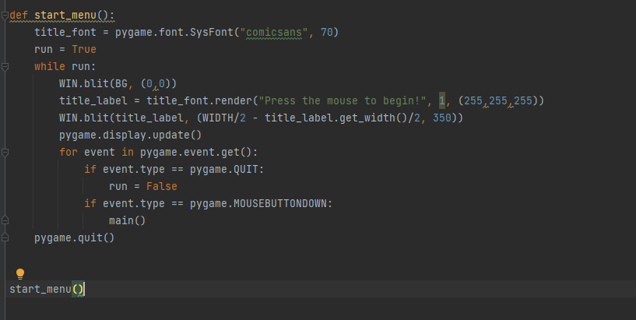

Start menu is the ,well menu before game starts.With clicking to the screen game starts.WIn.blit takes one of the asset images that are turned to surfaces and draws it into the location that is defined which is 0,0 in coordinate system.So the background is drawn starting from 0,0 and covers the page.

Techniques used in this game is that since it is a game,it requires user input in order to play.So a constant interaction between man and machine is required.Keyboard inputs are constantly used in the GUI.Since it is a game it also has a user interface.Game begins just by clicking the screen, so there is no main menu with settings such as Play button,settings button and exit button,but they can be added.All these functions contain Human Computer Interaction functionality techniques.